Dynamic Host Configuration Protocol:

1. The Dynamic Host Configuration Protocol (DHCP) provides configuration parameters to Internet hosts.
2. DHCP is built on a client-server model, where designated DHCP server hosts allocate network addresses and deliver configuration parameters to dynamically configured hosts.
3. The term "server" refers to a host providing initialization parameters through DHCP .
4. The term "client" refers to a host requesting initialization parameters from a DHCP server.
For example, IP requires the setting of many parameters within the protocol implementation software.Because IP can be used on many dissimilar kinds of network hardware,values for those parameters cannot be guessed or assumed to have correct defaults. Also,distributed address allocation schemes depend on a polling/defense mechanism for discovery of addresses that are already in use. IP hosts may not always be able to defend their network addresses, so that such a distributed address allocation scheme cannot be guaranteed to avoid allocation of duplicate network addresses

DHCP supports three mechanisms for IP address allocation.
Manual allocation (MAC address)
This method entails using DHCP to identify the unique hardware address of each network card connected to the network and then continually supplying a constant configuration each time the DHCP client makes a request to the DHCP server using that network device. This ensures that a particular address is assigned automatically to that network card, based on it's MAC address.
Dynamic allocation (address pool)
In this method, the DHCP server will assign an IP address from a pool of addresses (sometimes also called a range or scope) for a period of time or lease, that is configured on the server or until the client informs the server that it doesn't need the address anymore. This way, the clients will be receiving their configuration properties dynamically and on a "first come, first served" basis. When a DHCP client is no longer on the network for a specified period, the configuration is expired and released back to the address pool for use by other DHCP Clients. This way, an address can be leased or used for a period of time. After this period, the client has to renegociate the lease with the server to maintain use of the address.
Automatic allocation
Using this method, the DHCP automatically assigns an IP address permanently to a device,selecting it from a pool of available addresses. Usually DHCP is used to assign a temporary address to a client, but a DHCP server can allow an infinite lease time.
The last two methods can be considered "automatic" because in each case the DHCP server assigns an address with no extra intervention needed. The only difference between them is in how long the IP address is leased, in other words whether a client's address varies over time.

DHCP is an extension of the BOOTP mechanism. This behavior allows existing BOOTP clients to interoperate with DHCP servers without requiring any change to the clients' initialization software.

op (1) htype (1) hlen (1) hops (1)

xid (4) (Trasaction ID)

secs (2) flags (2)

ciaddr (4) (client identifier address)

yiaddr (4) (your identifier address)

server identifier address (4)

giaddr (4) (relay agent ip address)

client identifier address (16)

sname (64) (server host name)

file (128) (Boot file name)

options (variable)

DHCP defines a new 'client identifier' option that is used to pass an explicit client identifier to a DHCP server. This change eliminates the overloading of the 'chaddr' field in BOOTP messages, where 'chaddr' is used both as a hardware address for transmission of BOOTP reply messages and as a client identifier. The 'client identifier' is an opaque key, not to be interpreted by the server

For Example,
The 'client identifier' may contain a hardware address, identical to the contents of the 'chaddr' field, or it may contain another type of identifier, such as a DNS name. The 'client identifier' chosen by a DHCP client must be unique to that client within the subnet to which the client is attached. If the client uses a 'client identifier' in one message, it must use that same identifier in all subsequent messages, to ensure that all servers correctly identify the client.

DHCP clarifies the interpretation of the 'siaddr' field as the address of the server to use in the next step of the client's bootstrap process. A DHCP server may return its own address in the 'siaddr' field, if the server is prepared to supply the next bootstrap service (e.g., delivery of an operating system executable image). A DHCP server always returns its own address in the 'server identifier' option.

DHCP Fields

Operation : (1 octet) Message op code / message type.
1 = BOOTREQUEST, 2 = BOOTREPLY
Hardware Address Type : (1 octet ) Hardware address type, see ARP section in "Assigned Numbers" RFC; e.g., '1' = 10mb ethernet.

Hardware Address Length : (1 octet) Hardware address length (e.g. '6' for 10mb ethernet).

Hops : (1 octet) Client sets to zero, optionally used by relay agents when booting via a relay agent.

Xid (Trasaction ID) : (4 octet) Transaction ID, a random number chosen by the client, used by the client and server to associate messages and responses between a client and a server.

Secs : (2 octet ) Filled in by client, seconds elapsed since client began address acquisition or renewal process.

flags : (2 octet) Flags (see figure 2).

ciaddr : (4 octet) Client IP address; only filled in if client is inBOUND, RENEW or REBINDING state and can respond to ARP requests.

Yiaddr : (4 octet) 'your' (client) IP address.

Siaddr : (4 octet) IP address of next server to use in bootstrap; returned in DHCPOFFER, DHCPACK by server.

Giaddr : (4 octet) Relay agent IP address, used in booting via a relay agent.

Chaddr : (16 octet) Client hardware address.

Sname : (64 octet) Optional server host name, null terminated string.

File : (128 octet) Boot file name, null terminated string; "generic" name or null in DHCPDISCOVER, fully qualified directory-path name in DHCPOFFER.

options : (variable length) Optional parameters field. See the options documents for a list of defined options.

The 'options' field is now variable length. A DHCP client must be prepared to receive DHCP messages with an 'options' field of at least length 312 octets. This requirement implies that a DHCP client must be prepared to receive a message of up to 576 octets, the minimum IP
datagram size an IP host must be prepared to accept. DHCP clients may negotiate the use of larger DHCP messages through the 'maximum DHCP message size' option.The options field may be further extended into the 'file' and 'sname' fields.

To work around some clients that cannot accept IP unicast datagrams before the TCP/IP software is configured. The DHCP uses the 'flags' field. The leftmost bit is defined as the BROADCAST (B) flag. The remaining bits of the flags field are reserved for future use. They must be set to zero by clients and ignored by servers and relay agents.

The Configuration Parameters

The first service provided by DHCP is to provide persistent storage of network parameters for network clients. The model of DHCP persistent storage is that the DHCP service stores a key-value entry for each client, where the key is some unique identifier
For Example, an IP subnet number and a unique identifier within the subnet and the value contains the configuration parameters for the cient.

The second service provided by DHCP is the allocation of temporary or permanent network (IP) addresses to clients. The basic mechanism for the dynamic allocation of network addresses is simple: a client requests the use of an address for some period of time.The allocation mechanism (the collection of DHCP servers) guarantees not to reallocate that address within the requested time and attempts to return the same network address each time the client requests an address.
In this document, the period over which a network address is allocated to a client is referred to as a lease. The client may extend its lease with subsequent requests. The client may issue a message to release the address back to the server when the client no longer needs the address. The client may ask for a permanent assignment by asking for an infinite lease. Even when assigning permanent addresses, a server may choose to give out lengthy but non-infinite leases to allow detection of the fact that the client has been retired.

In some environments it will be necessary to reassign network addresses due to exhaustion of available addresses. In such environments, the allocation mechanism will reuse addresses whose lease has expired. The server should use whatever information is available in the configuration information repository to choose an address to reuse. For example, the server may choose the least recently assigned address. As a consistency check, the allocating server should probe the reused address before allocating the address,

e.g., with an ICMP echo request, and the client should probe the newly received address, e.g., with ARP.

The Client-Server Protocol

The op field of each DHCP message sent from a client to a server contains BOOTREQUEST. BOOTREPLY is used in the op field of each DHCP message sent from a server to a client.

The first four octets of the options field of the DHCP message contain the (decimal) values 99, 130, 83 and 99, respectively (this is the same magic cookie)

Vendor Information "Magic Cookie"(rfc 1497)

The first four bytes of this field have been assigned to the magic cookie, which identifies the mode in which the succeeding data is to be interpreted.The value of the magic cookie is the 4 octet dotted decimal 99.130.83.99 (or hexadecimal number 63.82.53.63) in network byte order.
The remainder of the options field consists of a list of tagged parameters that are called options (rfc 1533).

DHCP Option Field Format
Options may be fixed length or variable length. All options begin with a tag octet, which uniquely identifies the option. Fixed-length options without data consist of only a tag octet.
Only options 0 and 255 are fixed length. All other options are variable-length with a length octet following the tag octet. The value of the length octet does not include the two octets specifying the tag and length. The length octet is followed by length octets of data. In the case of some variable-length options the length field is a constant but must still be specified.

1) Pad Option

The pad option can be used to cause subsequent fields to align on word boundaries.

The code for the pad option is 0, and its length is 1 octet.
Code : 0

2) End Option

The end option marks the end of valid information in the vendor
field.Subsequent octets should be filled with pad options.

The code for the end option is 255, and its length is 1 octet.
End : 255

3) Subnet Mask
The subnet mask option specifies the client's subnet mask . If both the subnet mask and the router option are specified in a DHCP reply, the subnet mask option must be first.

The code for the subnet mask option is 1, and its length is 4 octets.
Code Len Subnet Mask
1 4 m1 m2 m3 m4

4) Time Offset
The time offset field specifies the offset of the client's subnet in seconds from Coordinated Universal Time (UTC). The offset is expressed as a signed 32-bit integer.

The code for the time offset option is 2, and its length is 4 octets.
Code Len Time Offset
2 4 m1 m2 m3 m4

5) Router Option

The router option specifies a list of IP addresses for routers on the client's subnet. Routers should be listed in order of preference.
The code for the router option is 3. The minimum length for the router option is 4 octets, and the length must always be a multiple of 4.

Code Len address address
3 n a1 a2 a3 a4 a1 a2 a3 . . .

5) Name Server Option

The name server option specifies a name server available to the client. Servers should be listed in order of preference.

The code for the name server option is 5. The minimum length for this option is 4 octets, and the length must always be a multiple of 4.

Code Len address1 address2
5 n a1 a2 a3 a4 a1 a2 a3 . . .

6) Domain Name Server Option

The domain name server option specifies a list of Domain Name System name servers available to the client. Servers should be listed in order of preference.

The code for the domain name server option is 6. The minimum length for this option is 4 octets, and the length must always be a multiple of 4.

Code Len address1 address2
6 n a1 a2 a3 a4 a1 a2 a3 . . .

7) Requested IP Address
This option is used in a client request (DHCPDISCOVER) to allow the client to request that a particular IP address be assigned.

The code for this option is 50, and its length is 4.
Code Len address
50 4 a1 a2 a3 a4

8) IP Address Lease Time

This option is used in a client request (DHCPDISCOVER or DHCPREQUEST) to allow the client to request a lease time for the IP address. In a server reply (DHCPOFFER), a DHCP server uses this option to specify he lease time it is willing to offer.The time is in units of seconds, and is specified as a 32-bit unsigned integer.

The code for this option is 51, and its length is 4.
Code Len Lease Time
51 4 t1 t2 t3 t4

9) DHCP Message Type

This option is used to convey the type of the DHCP message. The code for this option is 53, and its length is 1. Legal values for this
option are:
Value Message Type
----- ------------
1 DHCPDISCOVER
2 DHCPOFFER
3 DHCPREQUEST
4 DHCPDECLINE
5 DHCPACK
6 DHCPNAK
7 DHCPRELEASE
Code Len Type
53 1 1-7

10) Server Identifier

This option is used in DHCPOFFER and DHCPREQUEST messages, and may optionally be included in the DHCPACK and DHCPNAK messages. DHCP servers include this option in the DHCPOFFER in order to allow the client to distinguish between lease offers. DHCP clients indicate which of several lease offers is being accepted by including this option in a DHCPREQUEST message.

The identifier is the IP address of the selected server.

The code for this option is 54, and its length is 4.

Code Len address
54 4 a1 a2 a3 a4

11) Parameter Request List

This option is used by a DHCP client to request values for specifie configuration parameters. The list of requested parameters is specified as n octets, where each octet is a valid DHCP option code as defined in this document.

The code for this option is 55. Its minimum length is 1

Code Len Option Codes
55 n c1 c2 . . .

12) Renewal (T1) Time Value
This option specifies the time interval from address assignment until the client transitions to the RENEWING state.

The value is in units of seconds, and is specified as a 32-bit unsigned integer.

The code for this option is 58, and its length is 4.
Code Len T1 Interval
58 4 t1 t2 t3 t4

13) Rebinding (T2) Time Value

This option specifies the time interval from address assignment until the client transitions to the REBINDING state.

The value is in units of seconds, and is specified as a 32-bit unsigned integer.

The code for this option is 59, and its length is 4.

Code Len T2 Interval
58 4 t1 t2 t3 t4

14) Client-identifier

This option is used by DHCP clients to specify their unique identifier. DHCP servers use this value to index their database of address bindings. This value is expected to be unique for all clients in an administrative domain.

Identifiers consist of a type-value pair, similar to the

It is expected that this field will typically contain a hardware type and hardware address, but this is not required. Current legal values for hardware types

The code for this option is 61, and its minimum length is 2.

Code Len type Client Identifier
58 4 t1 i2 i3 . . .

Client-server interaction - allocating a network address

1. The client broadcasts a DHCPDISCOVER message on its local physical subnet. The DHCPDISCOVER message may include options that suggest values for the network address and lease duration. BOOTP relay agents may pass the message on to DHCP servers not on the same physical subnet.

2. Each server may respond with a DHCPOFFER message that includes an available network address in the 'yiaddr' field (and other configuration parameters in DHCP options). Servers need not reserve the offered network address, although the protocol will work more efficiently if the server avoids allocating the offered network address to another client. When allocating a new address,servers should check that the offered network address is not already in use;

Example
The server may probe the offered address with an ICMP Echo Request.Servers should be implemented so that network administrators may choose to disable probes of newly allocated addresses.The server transmits the DHCPOFFER message to the client, using the BOOTP relay agent if necessary.

Message Use
------- ---

DHCPDISCOVER - Client broadcast to locate available servers.

DHCPOFFER - Server to client in response to DHCPDISCOVER with offer of configuration parameters.

DHCPREQUEST - Client message to servers either (a) requesting offered parameters from one server and implicitly declining offers from all others, (b) confirming correctness of previously allocated address after,
Example : system reboot, or (c) extending the lease on a particular network address.
DHCPACK - Server to client with configuration parameters,including committed network address.

DHCPNAK - Server to client indicating client's notion of network address is incorrect (e.g., client has moved to new subnet) or client's lease as expired

DHCPDECLINE - Client to server indicating network address is already in use.

DHCPRELEASE - Client to server relinquishing network address and cancelling remaining lease.

DHCPINFORM - Client to server, asking only for local configuration parameters; client already has externally configured network address.

Timeing Diagram
Server Client Server
(not selected) (selected)

Begins initialization

DHCP DISCOVER
DHCP DISCOVER
Determines Determines
configuration configuration

DHCP OFFER
DHCP OFFER

Collects replies

Selects configuration
DHCP REQUEST

DHCP REQUEST
Commits configuration

ACK
Initialization complete
. . .
. . .
Graceful shutdown

DHCP RELEASE

Discards lease

V V V

3. The client receives one or more DHCPOFFER messages from one or more servers. The client may choose to wait for multiple responses.The client chooses one server from which to request configuration parameters, based on the configuration parameters offered in the DHCPOFFER messages. The client broadcasts a DHCPREQUEST message that must include the server identifier option to indicate which server it has selected, and that may include other options specifying desired configuration values. The requested IP address option must be set to the value of yiaddr in the DHCPOFFER message from the server. This DHCPREQUEST message is broadcast and relayed through DHCP/BOOTP relay agents. To help ensure that any BOOTP relay agents forward the DHCPREQUEST message to the same set of DHCP servers that received the original DHCPDISCOVER message, the DHCPREQUEST message must use the same value in the DHCP message header's secs field and be sent to the same IP broadcast address as the original DHCPDISCOVER message.The client times out and retransmits the DHCPDISCOVER message if the client receives no DHCPOFFER messages.

4. The servers receive the DHCPREQUEST broadcast from the client.Those servers not selected by the DHCPREQUEST message use the message as notification that the client has declined that server's offer. The server selected in the DHCPREQUEST message commits the binding for the client to persistent storage and responds with a DHCPACK message containing the configuration parameters for the requesting client. The combination of client identifier or chaddr and assigned network address constitute a unique identifier for the client's lease and are used by both the client and server to identify a lease referred to in any DHCP messages.Any configuration parameters in the DHCPACK message should not conflict with those in the earlier DHCPOFFER message to which the client is responding. The server should not check the offered network address at this point. The yiaddr field in the DHCPACK messages is filled in with the selected network address.

If the selected server is unable to satisfy the DHCPREQUEST message (e.g., the requested network address has been allocated), the server should respond with a DHCPNAK message.

A server may choose to mark addresses offered to clients in DHCPOFFER messages as unavailable. The server should mark an address offered to a client in a DHCPOFFER message as available if the server receives no DHCPREQUEST message from that client.

5. The client receives the DHCPACK message with configuration parameters. The client should perform a final check on the parameters (e.g., ARP for allocated network address), and notes the duration of the lease specified in the DHCPACK message. At this point, the client is configured. If the client detects that the address is already in use (e.g., through the use of ARP), the client must send a DHCPDECLINE message to the server and restarts the configuration process. The client should wait a minimum of ten seconds before restarting the configuration process to avoid excessive network traffic in case of looping.

If the client receives a DHCPNAK message, the client restarts the configuration process.
5) The client times out and retransmits the DHCPREQUEST message if the client receives neither a DHCPACK or a DHCPNAK message. The client retransmits the DHCPREQUEST according to the retransmission algorithm. The client should choose to retransmit the DHCPREQUEST enough times to give adequate probability of contacting the server without causing the client (and the user of that client) to wait overly long before giving up;
e.g., a client retransmitting the DHCPREQUEST message four times, for a total delay of 60 seconds, before restarting the initialization procedure. If the client receives neither a DHCPACK or a DHCPNAK message after employing the retransmission algorithm, the client reverts to INIT state and restarts the initialization process. The client should notify the user that the initialization process has failed and is restarting.

6) The client may choose to relinquish its lease on a network address by sending a DHCPRELEASE message to the server. The client identifies the lease to be released with its client identifier or chaddr and network address in the DHCPRELEASE message. If the client used a client identifier when it obtained the lease, it must use the same client identifier in the DHCPRELEASE message

Client-server interaction - reusing a previously allocated network address
1. The client broadcasts a DHCPREQUEST message on its local subnet.The message includes the client's network address in the requested IP address option. As the client has not received its network address, it must not fill in the ciaddr field. BOOTP relay agents pass the message on to DHCP servers not on the same subnet. If the client used a client identifier to obtain its address, the client must use the same client identifier in the DHCPREQUEST message.

2. Servers with knowledge of the client's configuration parameters respond with a DHCPACK message to the client. Servers should not check that the client's network address is already in use; the client may respond to ICMP Echo Request messages at this point.If the client's request is invalid (e.g., the client has moved to a new subnet), servers should respond with a DHCPNAK message to the client. Servers should not respond if their information is not guaranteed to be accurate. For example, a server that identifies a request for an expired binding that is owned by another server should not respond with a DHCPNAK unless the servers are using an explicit mechanism to maintain coherency among the servers.

Timeline diagram of messages exchanged between DHCP client and servers when reusing a previously allocated network address
server Client Server

Begins
initialization
DHCP REQUEST
DHCP REQUEST

Locates Locates
configuration configuration
DHCP ACK DHCP ACK

Initialization
complete
(Subsequent
DHCPACKS
ignored)

giaddr

If giaddr is 0x0 in the DHCPREQUEST message, the client is on the same subnet as the server. The server must broadcast the DHCPNAK message to the 0xffffffff broadcast address because the client may not have a correct network address or subnet mask, and the client may not be answering ARP requests. Otherwise, the server must send the DHCPNAK message to the IP address of the BOOTP relay agent, as recorded in giaddr. The relay agent will, in turn, forward the message directly to the client's hardware address, so that the DHCPNAK can be delivered even if the client has moved to a new network.

Interpretation and representation of time values
A client acquires a lease for a network address for a fixed period of time (which may be infinite). Throughout the protocol, times are to be represented in units of seconds. The time value of 0xffffffff is reserved to represent infinity.

As clients and servers may not have synchronized clocks, times are represented in DHCP messages as relative times, to be interpreted with respect to the client's local clock. Representing relative times in units of seconds in an unsigned 32 bit word gives a range of relative times from 0 to approximately 100 years, which is sufficient for the relative times to be measured using DHCP.

The algorithm for lease duration interpretation given in the previous paragraph assumes that client and server clocks are stable relative to each other. If there is drift between the two clocks, the server may consider the lease expired before the client does. To compensate, the server may return a shorter lease duration to the client than the server commits to its local database of client information.

Obtaining parameters with externally configured network address
If a client has obtained a network address through some other means (e.g., manual configuration), it may use a DHCPINFORM request message to obtain other local configuration parameters. Servers receiving a DHCPINFORM message construct a DHCPACK message with any local configuration parameters appropriate for the client without:allocating a new address, checking for an existing binding, filling in yiaddr or including lease time parameters. The servers should unicast the DHCPACK reply to the address given in the ciaddr field of the DHCPINFORM message.

DHCP server behavior

A DHCP server processes incoming DHCP messages from a client based on the current state of the binding for that client. A DHCP server can receive the following messages from a client:

i) DHCPDISCOVER

ii) DHCPREQUEST

iii) DHCPDECLINE

iv) DHCPRELEASE

v) DHCPINFORM

i) DHCPDISCOVER

Boot request (1) Ethernet (0x01) hlen : 6 hops: 0

xid (4) (Trasaction ID) : 0x0000155E

secs (2) : 0 flags (2) : 1... .... .... (broadcast)

ciaddr (4) (client identifier address) : 0.0.0.0

yiaddr (4) (your identifier address) : 0.0.0.0

server identifier address (4) : 0.0.0.0

giaddr (4) (relay agent ip address) : 0.0.0.0

client identifier address (16) : 0001:968B:DCD9

sname (64) (server host name) : not given

file (128) (Boot file name) : not given

Magie cookie : 99.130.83.99 (or hexadecimal number 63.82.53.63) (DHCP)

options : (len : 2) (53) DHCP Message Type (Discover)

(57) Maximum DHCP Message Size : 1152 (len : 2)

(12) Host Name : R0 (len : 2)

(55) parameter list : (len : 9)
(1) Subnet Mask
(6) Domain Name Server
(15) Domain Name
(3) Router
(51) IP address lease time
(58) Renewal time value
(59) Rebinding time value
(54) DHCP Server Identifier
(28) Broadcast Address

(255) End

The DHCP uses the UDP as the
source port as : 67 ,destination port : 68 , Length and checksum.
In the Ipv4 header
Protocol field = 17 (UDP)
Source IP = 0.0.0.0
destination IP = 255.255.255.255
In the Ethernet Header
Source mac : 0001:968B:DCD9
Destination mac : ffff:ffff:ffff
Type field : (0x0800) IP
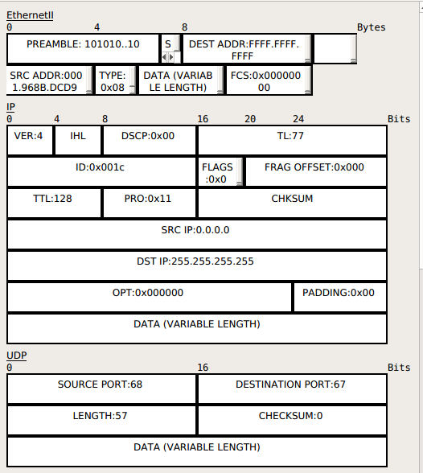

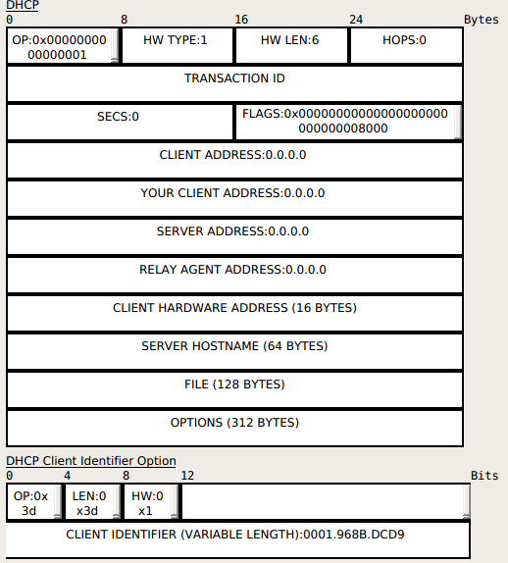

When a server receives a DHCPDISCOVER message from a client, the server chooses a network address for the requesting client. If no address is available, the server may choose to report the problem to the system administrator. If an address is available, the new address
should be chosen as follows:

1) The client's current address as recorded in the client's current binding, ELSE

2) The client's previous address as recorded in the client's (no expired or released) binding, if that address is in the server's pool of available addresses and not already allocated, ELSE

3) The address requested in the Requested IP Address option, if tha address is valid and not already allocated, ELSE

4) A new address allocated from the server's pool of available addresses; the address is selected based on the subnet from which the message was received (if giaddr is 0) or on the address of the relay agent that forwarded the message (giaddr when not 0).

i) DHCPOFFER

Boot reply (2) Ethernet (0x01) hlen : 6 hops: 0

xid (4) (Trasaction ID) : 0x0000155E

secs (2) : 0 flags (2) : 1... .... .... (broadcast)

ciaddr (4) (client identifier address) : 0.0.0.0

yiaddr (4) (your identifier address) : 10.0.0.7

server identifier address (4) : 10.0.0.1
z
giaddr (4) (relay agent ip address) : 0.0.0.0

client identifier address (16) : 0001:968B:DCD9

sname (64) (server host name) : nhostapd startot given

file (128) (Boot file name) : not given

Magie cookie : 99.130.83.99 (or hexadecimal number 63.82.53.63) (DHCP)

options : (len : 1) (53) DHCP Message Type (Offer (2))

(54) DHCP server identifier : 10.0.0.1 (len : 4)

(51) IP Address Lease Time = (60s) 1 minute (len :4)

(1) Subnet mask : 255.255.255.0 (len : 4)

(3) Router : 10.0.0.2 (len : 4)

(6) Domain Name Server : 10.0.0.81 (DNS)

(15) Domain Name : example.org (len : 11)

(58) Renewal Time Value = (30s) 30 Seconds (len : 4)

(59) Rebinding Time Value = (52 s) 52 Seconds (len : 4)

(255 ) End

The DHCP uses the UDP as the
source port as : 67 ,destination port : 68 , Length and checksum.
In the Ipv4 header
Protocol field = 17 (UDP)
Source IP = 10.0.0.1
destination IP = 255.255.255.255
In the Ethernet Header
Source mac : 0001:C77C.8001
Destination mac : ffff:ffff:ffff
Type field : (0x0800) IP
DHCP OFFER Packet

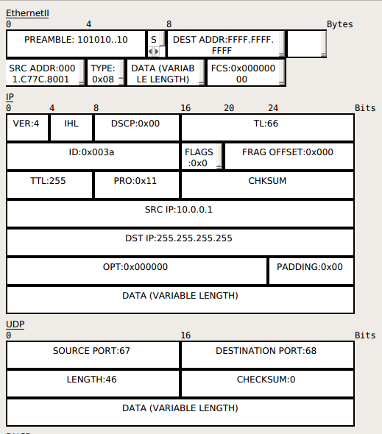

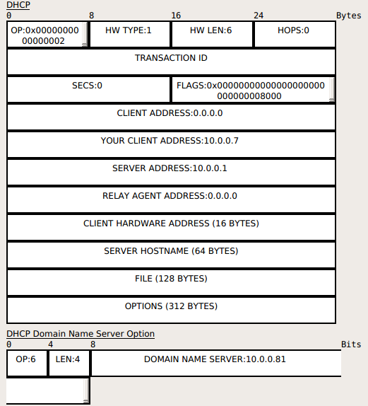

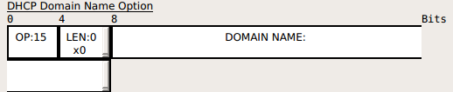

Once the network address and lease have been determined, the server constructs a DHCPOFFER message with the offered configuration parameters. It is important for all DHCP servers to return the same parameters (with the possible exception of a newly allocated network address) to ensure predictable client behavior regardless of which server the client selects. The configuration parameters must be selected by applying the following rules in the order given below.The network administrator is responsible for configuring multiple DHCP servers to ensure uniform responses from those servers.
The server must return to the client:

1) The client's network address, as determined by the rules given earlier in this section,

2) The expiration time for the client's lease, as determined by the rules given earlier in this section,

3) Parameters requested by the client, according to the following rules:

DHCPREQUEST message

Boot reply (2) Ethernet (0x01) hlen : 6 hops: 0

xid (4) (Trasaction ID) : 0x0000155E

secs (2) : 0 flags (2) : 1... .... .... (broadcast)(0x8000)

ciaddr (4) (client identifier address) : 0.0.0.0

yiaddr (4) (your identifier address) : 0.0.0.0

server identifier address (4) : 0.0.0.0

giaddr (4) (relay agent ip address) : 0.0.0.0

client identifier address (16) : 0001:968B:DCD9

sname (64) (server host name) : not given

file (128) (Boot file name) : not given

Magie cookie : 99.130.83.99 (or hexadecimal number 63.82.53.63) (DHCP)

options : (len : 1) (53) DHCP Message Type (Request (1))

(57) Maximum DHCP message size : 1152 (len : 2)

(54) DHCP server identifier : 10.0.0.1 (4)

(51) IP Address Lease Time = (60s) 1 minute (len :4)

(50) Requested IP address : 10.0.0.7
( 55) parameter list : (len : 8)
(1) Subnet Mask
(6) Domain Name Server
(15) Domain Name
(3) Router
(51) IP address lease time
(58) Renewal time value
(59) Rebinding time value
(54) DHCP Server Identifier
(28) Broadcast Address

(255) End

The DHCP uses the UDP as the
source port as : 68 ,destination port : 67 , Length and checksum.
In the Ipv4 header
Protocol field = 17 (UDP)
Source IP = 0.0.0.0
destination IP = 255.255.255.255
In the Ethernet Header
Source mac : 0001:968B:DCD9 (client mac address)
Destination mac : ffff:ffff:ffff
Type field : (0x0800) IP

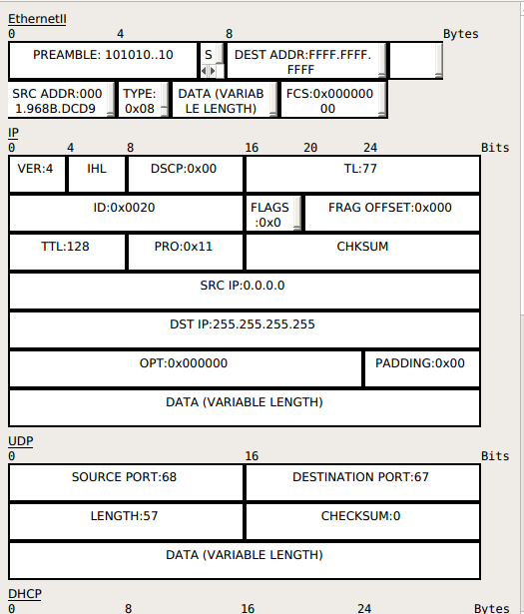

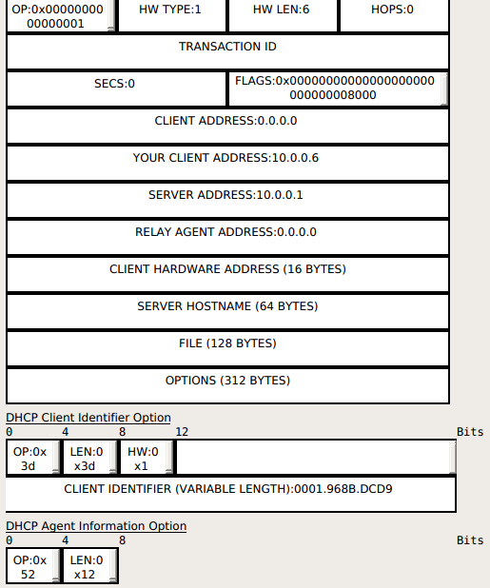

DHCPREQUEST message may come from a client responding to a DHCPOFFER message from a server, from a client verifying a previously allocated IP address or from a client extending the lease on a network address. If the DHCPREQUEST message contains a server identifier option, the message is in response to a D message.

Otherwise, the message is a request to verify or extend an existing lease. If the client uses a client identifier in a DHCPREQUEST message, it must use that same client identifier in all subsequent messages. If the client included a list of requested parameters in a DHCPDISCOVER message, it must include that list in all subsequent messages.

DHCPREQUEST generated during SELECTING state
Client inserts the address of the selected server in server identifier, ciaddr must be zero, requested IP address must be filled in with the yiaddr value from the chosen DHCPOFFER.

DHCPREQUEST generated during INIT REBOOT state:

server identifier must not be filled in, requested IP address option must be filled in with client's notion of its previously assigned address. ciaddr must be zero. The client is seeking to verify a previously allocated, cached configuration. Server should send a DHCPNAK message to the client if the requested IP address is incorrect, or is on the wrong network.

Determining whether a client in the INIT-REBOOT state is on the correct network is done by examining the contents of giaddr, the requested IP address option, and a database lookup. If the DHCP server detects that the client is on the wrong net (i.e., the result of applying the local subnet mask or remote subnet mask (if giaddr is not zero) to requested IP address option value doesn't match reality), then the server should send a DHCPNAK message to the client

If the network is correct, then the DHCP server should check if the client's notion of its IP address is correct. If not, then the server should send a DHCPNAK message to the client. If the DHCP server has no record of this client, then it must remain silent,and may output a warning to the network administrator. This behavior is necessary for peaceful coexistence of non communicating DHCP servers on the same wire.

If giaddr is set in the DHCPREQUEST message, the client is on a different subnet. The server must set the broadcast bit in the DHCPNAK, so that the relay agent will broadcast the DHCPNAK to the client, because the client may not have a correct network address or subnet mask, and the client may not be answering ARP requests.

DHCPREQUEST generated during REBINDING state:
server identifier must not be filled in, requested IP address option must not be filled in,ciaddr must be filled in with client's IP address. In this situation, the client is completely configured, and is trying to extend its lease. This message must be broadcast to the 0xffffffff IP broadcast address. The DHCP server should check ciaddr for correctness before replying to the DHCPREQUEST.

The DHCPREQUEST from a REBINDING client is intended to accommodate sites that have multiple DHCP servers and a mechanism for maintaining consistency among leases managed by multiple servers.A DHCP server may extend a client's lease only if it has local administrative authority to do so.

DHCPRELEASE message
Upon receipt of a DHCPRELEASE message, the server marks the network address as not allocated. The server should retain a record of the client's initialization parameters for possible reuse in response to subsequent requests from the client.

DHCPINFORM message

The server responds to a DHCPINFORM message by sending a DHCPACK message directly to the address given in the ciaddr field of the DHCPINFORM message. The server must not send a lease expiration time to the client and should not fill in yiaddr. The server includes other parameters in the DHCPACK message.

i) DHCPACK

Boot reply (2) Ethernet (0x01) hlen : 6 hops: 0

xid (4) (Trasaction ID) : 0x0000155E

secs (2) : 0 flags (2) : 1... .... .... (broadcast)

ciaddr (4) (client identifier address) : 0.0.0.0

yiaddr (4) (your identifier address) : 10.0.0.7

server identifier address (4) : 10.0.0.1

giaddr (4) (relay agent ip address) : 0.0.0.0

client identifier address (16) : 0001:968B:DCD9

sname (64) (server host name) : not given

file (128) (Boot file name) : not given

Magie cookie : 99.130.83.99 (or hexadecimal number 63.82.53.63) (DHCP)

options : (len : 1) (53) DHCP Message Type (ACK (5))

(54) DHCP server identifier : 10.0.0.1 (4)

(51) IP Address Lease Time = (60s) 1 minute (len :4)

(1) Subnet Mask : 255.255.255.0 (len : 4)

(3) Router : 10.0.0.2 (len : 4)
(6) Domain Name Server : 10.0.0.81

(12) Host Name : example.org (len :11)

(255) End

The DHCP uses the UDP as the
source port as : 67 ,destination port : 68 , Length and checksum.
In the Ipv4 header
Protocol field = 17 (UDP)
Source IP = 10.0.0.1
destination IP = 255.255.255.255
In the Ethernet Header
Source mac : 0001:C77C.8001
Destination mac : ffff:ffff:ffff
Type field : (0x0800) IP

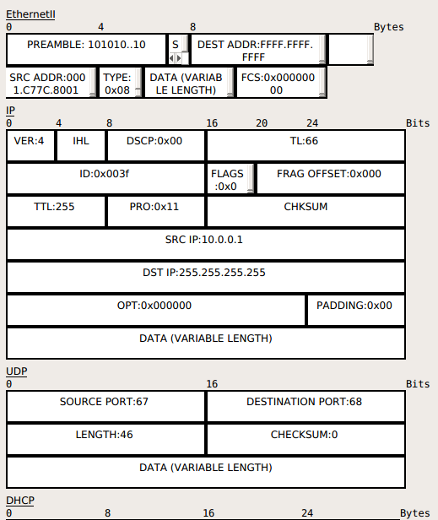

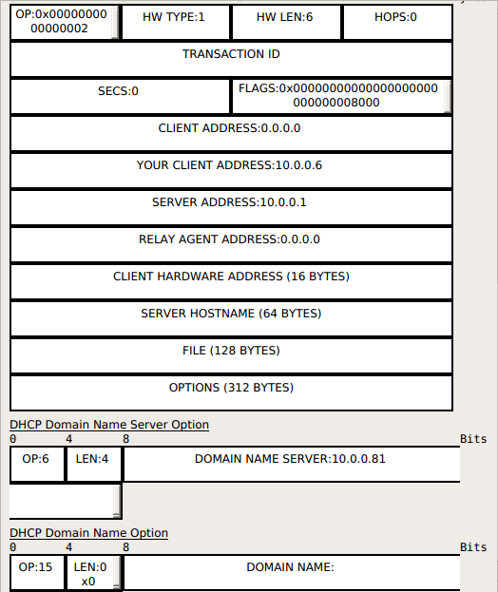

DHCPDECLINE message

If the server receives a DHCPDECLINE message, the client has discovered through some other means that the suggested network address is already in use. The server must mark the network address as not available and should notify the local system administrator of a possible configuration problem.

Graditous ARP Packet for finding the duplication of the ip address

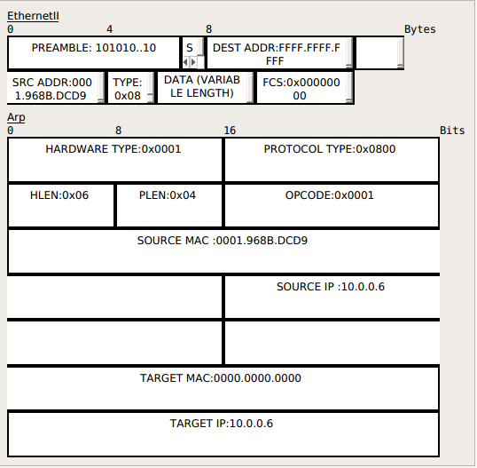

DHCPREQUEST generated during RENEWING state:
server identifier must not be filled in, requested IP address option must not be filled in, ciaddr must be filled in with client's IP address. In this situation, the client is completely configured, and is trying to extend its lease. This message will be unicast, so no relay agents will be involved in its transmission. Because giaddr is therefore not filled in, the DHCP server will trust the value in ciaddr, and use it when replying to the client.

A client may choose to renew or extend its lease prior to T1. The server may choose not to extend the lease (as a policy decision by the network administrator), but should return a DHCPACK message regardless.

Boot reply (2) Ethernet (0x01) hlen : 6 hops: 0

xid (4) (Trasaction ID) : 0x0000155E

secs (2) : 0 flags (2) : 0... .... .... (unicast)

ciaddr (4) (client identifier address) : 10.0.0.7

yiaddr (4) (your identifier address) : 0.0.0.0

server identifier address (4) : 10.0.0.1

giaddr (4) (relay agent ip address) : 0.0.0.0

client identifier address (16) : 0001:968B:DCD9

sname (64) (server host name) : not given

file (128) (Boot file name) : not given

Magie cookie : 99.130.83.99 (or hexadecimal number 63.82.53.63) (DHCP)

options : (len : 1) (53) DHCP Message Type (Request(3))

(54) DHCP server identifier : 10.0.0.1 (4)

(51) IP Address Lease Time = (60s) 1 minute (len :4)

(1) Subnet Mask : 255.255.255.0 (len : 4)

(3) Router : 10.0.0.2 (len : 4)
(6) Domain Name Server : 10.0.0.81

(12) Host Name : example.org (len :11)

(55) parameter list : (len : 9)
(1) Subnet Mask
(6) Domain Name Server
(15) Domain Name
(3) Router
(51) IP address lease time
(58) Renewal time value
(59) Rebinding time value
(54) DHCP Server Identifier
(28) Broadcast Address

(57) Maximum DHCP Message Size (576) (len : 2)

(255) End

The DHCP uses the UDP as the
source port as : 68 ,destination port : 67 , Length and checksum.
In the Ipv4 header
Protocol field = 17 (UDP)
Source IP = 10.0.0.7
destination IP = 10.0.0.1
In the Ethernet Header
Source mac : 0001:968B:DCD9
Destination mac 0001:C77C.8001
Type field : (0x0800) IP

DHCPACK generated during RENEWING state:

Boot reply (2) Ethernet (0x01) hlen : 6 hops: 0

xid (4) (Trasaction ID) : 0x0000155E

secs (2) : 0 flags (2) : 0... .... .... (unicast)

ciaddr (4) (client identifier address) : 10.0.0.7

yiaddr (4) (your identifier address) : 10.0.0.7

server identifier address (4) : 10.0.0.1

giaddr (4) (relay agent ip address) : 0.0.0.0

client identifier address (16) : 0001:968B:DCD9

sname (64) (server host name) : not given

file (128) (Boot file name) : not given

Magie cookie : 99.130.83.99 (or hexadecimal number 63.82.53.63) (DHCP)

options : (len : 1) (53) DHCP Message Type (ACK (5))

(54) DHCP server identifier : 10.0.0.1 (4)

(51) IP Address Lease Time = (60s) 1 minute (len :4)

(1) Subnet Mask : 255.255.255.0 (len : 4)

(3) Router : 10.0.0.2 (len : 4)
(6) Domain Name Server : 10.0.0.81

(12) Host Name : example.org (len :11)
(255) End
The DHCP uses the UDP as the
source port as : 67,destination port : 68, Length and checksum.
In the Ipv4 header
Protocol field = 17 (UDP)
Source IP = 10.0.0.1 (server ip)
destination IP = 10.0.0.7 (client ip assigned by DHCP Server)
In the Ethernet Header
Source mac : 0001:C77C.8001 ( server mac)
Destination mac : 0001:968B:DCD9 (clien mac)
Type field : (0x0800) IP

DHCPREQUEST generated during REBINDING state:
server identifier must not be filled in, requested IP address option must not be filled in,ciaddr must be filled in with client's IP address. In this situation, the client is completely configured, and is trying to extend its lease. This message must be broadcast to the 0xffffffff IP broadcast address. The DHCP server should check ciaddr for correctness before replying to the DHCPREQUEST.

The DHCPREQUEST from a REBINDING client is intended to accommodate sites that have multiple DHCP servers and a mechanism for maintaining consistency among leases managed by multiple servers.A DHCP server may extend a client's lease only if it has local administrative authority to do so.

Boot reply (2) Ethernet (0x01) hlen : 6 hops: 0

xid (4) (Trasaction ID) : 0x0000155E

secs (2) : 0 flags (2) : 0... .... .... (unicast)

ciaddr (4) (client identifier address) : 10.0.0.7

yiaddr (4) (your identifier address) : 0.0.0.0

server identifier address (4) : 0.0.0.0

giaddr (4) (relay agent ip address) : 0.0.0.0

client identifier address (16) : 0001:968B:DCD9

sname (64) (server host name) : not given

file (128) (Boot file name) : not given

Magie cookie : 99.130.83.99 (or hexadecimal number 63.82.53.63) (DHCP)

options : (len : 1) (53) DHCP Message Type (Request(3))

(54) DHCP server identifier : 10.0.0.1 (4)

(51) IP Address Lease Time = (60s) 1 minute (len :4)

(1) Subnet Mask : 255.255.255.0 (len : 4)

(3) Router : 10.0.0.2 (len : 4)
(6) Domain Name Server : 10.0.0.81

(12) Host Name : example.org (len :11)

(55) parameter list : (len : 9)
(1) Subnet Mask
(6) Domain Name Server
(15) Domain Name
(3) Router
(51) IP address lease time
(58) Renewal time value
(59) Rebinding time value
(54) DHCP Server Identifier
(28) Broadcast Address

(57) Maximum DHCP Message Size (576) (len : 2)

(255) End

The DHCP uses the UDP as the
source port as : 68 ,destination port : 67 , Length and checksum.
In the Ipv4 header
Protocol field = 17 (UDP)
Source IP = 10.0.0.7 (client ip)
destination IP = 255.255.255.255
In the Ethernet Header
Source mac : 0001:968B:DCD9 (client mac)
Destination mac : ffff:ffff:ffff (Boardcast mac)
Type field : (0x0800) IP

DHCPACK generated during REBINDING state:

Boot reply (2) Ethernet (0x01) hlen : 6 hops: 0

xid (4) (Trasaction ID) : 0x0000155E

secs (2) : 0 flags (2) : 0... .... .... (unicast)

ciaddr (4) (client identifier address) : 10.0.0.7

yiaddr (4) (your identifier address) : 10.0.0.7

server identifier address (4) : 10.0.0.1

giaddr (4) (relay agent ip address) : 0.0.0.0

client identifier address (16) : 0001:968B:DCD9

sname (64) (server host name) : not given

file (128) (Boot file name) : not given

Magie cookie : 99.130.83.99 (or hexadecimal number 63.82.53.63) (DHCP)

options : (len : 1) (53) DHCP Message Type (ACK (5))

(54) DHCP server identifier : 10.0.0.1 (4)

(51) IP Address Lease Time = (60s) 1 minute (len :4)

(1) Subnet Mask : 255.255.255.0 (len : 4)

(3) Router : 10.0.0.2 (len : 4)
(6) Domain Name Server : 10.0.0.81

(12) Host Name : example.org (len :11)
(255) End

The DHCP uses the UDP as the
source port as : 67,destination port : 68, Length and checksum.
In the Ipv4 header
Protocol field = 17 (UDP)
Source IP = 10.0.0.1 (server ip)
destination IP = 10.0.0.7 (client ip assigned by DHCP Server)
In the Ethernet Header
Source mac : 0001:C77C.8001 ( server mac)
Destination mac : 0001:968B:DCD9 (clien mac)
Type field : (0x0800) IP

Dynamic Host Configuration Protocol
>
INIT
INIT REBOOT
DHCPNAK restart > <
send DHCPREQUEST > <
DHCP ACK
REBOOTING
DHCP NAK (not accept)/ -/Send DHCPDISCOVER
Discard Offer Send DHCPDECLINE V
< DHCP offer
SELECTING
DHCP ACK Collect
Record lease,set Selects DHCPOFFER replies
timer T1,T2 V sends the DHCPREQUEST
REQUESTING
>
DHCP OFFER
Discard DHCP ACK/
Record lease, set DHCP NAK Lease Expired
timers T1,T2 Halt Network DHCP NAK
Halt Network
REBINDING
V
BOUND
> <
> < ^
DHCP OFFER
DHCP ACK T1 expires DHCP ACK DHCP ACK
DHCPNAK/Discard send DHCP REQUEST Record lease, set Broadcast
to leasing server timers T1,T2 DHCP REQUEST
RENEWING

DHCP Spoofing Attack

DHCP spoofing occurs when an attacker attempts to respond to DHCP requests and trying to list themselves (spoofs) as the default gateway or DNS server, hence, initiating a man in the middle attack. With that, it is possible that they can intercept traffic from users before forwarding to the real gateway or perform DoS by flooding the real DHCP server with request to choke ip address resources.
1) Attacker activates DHCP server on VLAN.
2) Attacker replies to valid client DHCP requets.
3) Attacket assigns IP configuration information that establishes rougue device as client default gateway
4) Attacker establishes “man-in-the-middle”attack.
The attacker will gives the wrong gateway.It is someting called as man in the middle attacks were rough DHCP server will give the wrong information.

To overcome this we have feature called DHCP Snooping
1) DHCP Snooping allows the configuration of ports as trusted or untrusted
2) Untrusted Port can not process DHCP replies.
3) Configure DHCP Snooping on uplinks to a DHCP Server.
4) Do not Configure DHCP Snooping on client ports.DHCP Snooping is an feature which can be configured on the switches.
When we configure DHCP Snooping on the Switches by default all the Switches Ports are Untrusted Ports.Untrusted Ports are the ports which cannot provide DHCP OFFER messages.If the switch receives any DHCP offer message it will simply drop the that perticular information.
What we can do is we can configure the port which is connected to DHCP as the Trusted Ports.
Which means the Trusted Port can only provide the DHCP offer messages.If the OFFER messages comes from Untrusted Ports it will simply drops the OFFER messages.
We don't need to configure on the client port because by default they are Untrusted Ports.
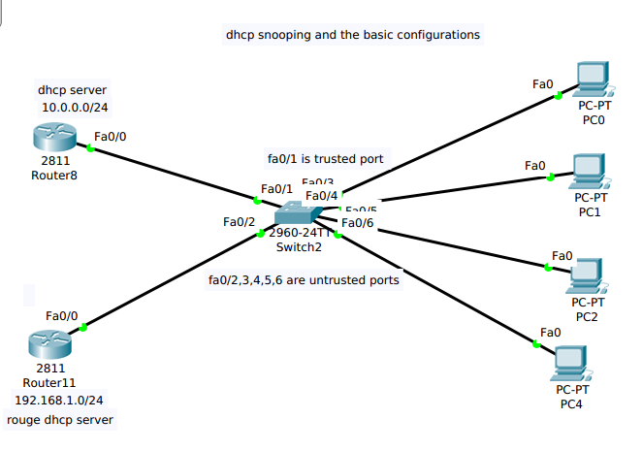

DHCP Snooping Configuration

ROUTER8 is the Trusted DHCP SERVER

router>en
router#config
router(config)#hostname r8
r8(config)#int f0/0
r8(config-if)#ip address 10.0.0.1 255.0.0.0
r8(config-if)#no shutdown
r8(config-if)#exit

r8(config)#ip dhcp pool cryto
r8(dhcp-config)#network 10.0.0.0 255.0.0.0
r8(dhcp-config)#default-router 10.0.0.1
r8(dhcp-config)#dns-server 10.0.0.80
r8(dhcp-config)#exit

r8(config)#ip dhcp excluded-address 10.0.0.1
r8(config)#ip dhcp excluded-address 10.0.0.80

ROUTER11 is the Untrusted DHCP SERVER as ROUGH SERVER

router>en
router#config
router(config)#hostname r11
r11(config)#int f0/0
r11(config-if)#ip address 192.168.1.1 255.255.255.0
r11(config-if)#no shutdown
r11(config-if)#exit

r11(config)#ip dhcp pool cryto
r11(dhcp-config)#network 192.168.1.0 255.255.255.0
r11(dhcp-config)#default-router 192.168.1.1
r11(dhcp-config)#dns-server 192.168.1.80
r11(dhcp-config)#exit

r11(config)#ip dhcp excluded-address 192.168.1.1
r11(config)#ip dhcp excluded-address 192.168.1.80

Configure the DHCP Snooping on the Switch2

switch>en
switch#config
switch(config)#hostname sw2
sw2(config)#ip dhcp snooping
sw2(config)#exit

sw2#sh ip dhcp binding
sw2#sh ip dhcp snooping

sw2#config
sw2(config)#ip dhcp snooping vlan 1
sw2(config)#int fa0/1 where trusted DHCP server is directly connected
sw2(config-if)#ip dhcp snooping trust
sw2(config-if)#exit

Here,the PC'S will not receive any OFFER message from the ROUTER11 because it is Untrusted port and recieves the OFFER message from the ROUTER8 because it is trusted port.

Internet Group Management Protocol (lGMP)
The Internet Group Management Protocol(IGMP) is used by IP hosts to report their multicast group membership to any immediately neighboring multicast routers.

This memo describes only the uses of IGMP between hosts and routers to determine group membership.Routers that are members of multicast group are expected to behave as hosts as well as routers and may even respond to their own queries.IGMP may also used between routers but such use is not specified here.

Like ICMP,IGMP are integral part of IP.It is required to be implemented by all hosts wishing to receive IP datagram IP multicasts IGMP messages are encapsulated in IP datagarm.

Multicast Application
Multicaste is the one to many,and also used in many useful applications,locating the multicast server.
For Example: The our laptop want to get the vedio stream and where is the server that actually sending that packet initially that those thing are not known to laptop

Your laptop come up where the multicast stream that you want to see usually that happen when you open an some browser which will send a unicast packet to some server and unicast packet some server will say give me the list of the multicast ip and server gives bunch of unicast packets back to you which will display in your laptop.
Here we don't see all this things of multicast addresses.When we click on the link we are doing two things
1) Sending a message to your default router by saying this perticular group it want to see her e special group address send them to me and i am interested in receiver that how router comes to know how there is a receiver overthere.So,the message is typically carried within IGMP.

Multicasting has many applications today such as access to distributed databases,information dissemination,teleconferencing and distance learning.

Access to Distributed Databases:
Most of the large databases today are distributed.That is,the information is stored in more than one location,usually at the time of production.The user who needs to access the database does not know the location of the information.A user's requet is multicasts to all the database locations,and the location that has the information responds.

Informaton Dissemination:
Business often need to send information to their customers.If the nature of the information is the same for each customer,it can be multicast.In this may a business can send one message that can reach many customers.For ex,a software update can be sent to all purchases of a perticular software package.

Multicast Addresses in IPV4
Although we have multicast addresses in both datalink and network link.In classless addressing the same block has been used for this purpose.In other words,the other

The Inter net Group Management Protocol (IGMP(v0)) is used by IP hosts to report their host group memberships to any immediately-neighboring multicast routers. IGMP is an asymmetric protocol and is specified here from the point of view of a host, rather than a multicast router. (IGMP may also be used, symmetrically or asymmetrically, between multicast routers.)
Like ICMP, IGMP is a integral part of IP. It is required to be implemented by all hosts conforming to level 2 of the IP multicasting specification. IGMP messages are encapsulated in IP datagrams, with an IP protocol number of 2.

Multicast routers send Host Membership Query messages (hereinafter called Queries) to discover which host groups have members on their attached local networks. Queries are addressed to the all-hosts group (address 224.0.0.1), and carry an IP time-to-live (TTL) of 1.
Hosts respond to a Query by generating Host Membership Reports (hereinafter called Reports), reporting each host group to which they belong on the network interface from which the Query was received. In order to avoid an "implosion" of concurrent Reports and to reduce the total number of Reports transmitted, two techniques are used:
1. When a host receives a Query, rather than sending Reports immediately, it starts a report delay timer for each of its group memberships on the network interface of the incoming Query. Each timer is set to a different, randomly-chosen value between zero and D seconds. When a timer expires, a report is generated for the corresponding host group. Thus, Reports are spread out over a D second interval instead of all occurring at once.
2. A Report is sent with an IP destination address equal to the host group address being reported, and with an IP time-to-live of 1, so that other members of the same group on the same network can overhear the Report. If a host hears a Report for a group to which it belongs on that network, the host stops its own timer for that group and does not generate a Report for that group. Thus, in the normal case, only one Report will be generated for each group present on the network, by the member host whose delay timer expires first. Note that the multicast routers receive all IP multicast datagrams, and therefore need not be addressed explicitly. Further note that the routers need not know which hosts belong to a group, only that at least one host belongs to a group on a particular network.
There are two exceptions to the behavior described above. First, if a report delay timer is already running for a group membership when a Query is received, that timer is not reset to a new random value, but rather allowed to continue running with its current value. Second, a report delay timer is never set for a host's membership in the all-hosts group (224.0.0.1), and that membership is never reported.
Multicast routers send Queries periodically to refresh their knowledge of memberships present on a particular network. If no Reports are received for a particular group after some number of Queries, the routers assume that that group has no local members and that they need not forward remotely-originated multicasts for that group onto the local network. Queries are normally sent infrequently (no more than once a minute) so as to keep the IGMP overhead on hosts and networks very low. However, when a multicast router starts up, it may issue several closely-space Queries in order to quickly build up its knowledge of local memberships.
When a host joins a new group, it should immediately transmit a Report for that group, rather than waiting for a Query, in case it is the first member of that group on the network. To cover the possibility of the initial Report being lost or damaged, it is recommended that it be repeated once or twice after short delays. A simple way to accomplish this is to act as if a Query had been received for that group only, setting the group's random report delay timer.

